

**CAPSTONE PROJECT REPORT**

**Report 4 – Software Design Document**

– HoChiMinh, September 2020 –

**Table of Contents**

I. Project Report 3

1. Status Report 3

2. Team Involvements 3

3. Issues/Suggestions 3

II. Software Design Document 4

1. Overall Description 4

1.1 Assumptions 4

1.2 Design Constraints 4

1.3 [Technology Suggestion] 5

2. System Architecture Design 5

2.1 Overall Architecture 5

2.2 System Architecture 5

2.3 Package Diagram 5

3. System Detailed Design 6

3.1 <Feature Name1> 6

4. Class Specifications 7

4.1 XYZ Class 7

4.2 ABC Class 7

4.3 … 8

5. Data & Database Design 8

5.1 Database Design 8

5.2 Data File Design 8

# I. Project Report

## 1. Status Report

|  |  |  |  |
| --- | --- | --- | --- |
| **#** | **Work Item** | **Status** | **Notes (Work Item in Details)** |
| 1 |  | Pending |  |
| 2 |  | In Progress |  |
| 3 |  | Completed |  |

## 2. Team Involvements

|  |  |  |  |
| --- | --- | --- | --- |
| **#** | **Task** | **Member** | **Notes (Task Details, etc.)** |
| 1 |  | Thaott |  |
| 2 |  | DatBC |  |
| 3 |  | Kiendst |  |
| 4 |  | MyTN |  |

## 3. Issues/Suggestions

|  |  |  |  |
| --- | --- | --- | --- |
| **#** | **Issue** | **Status** | **Notes (Solution, Suggestion, etc.)** |
| 1 |  | Pending |  |
| 2 |  | In Progress |  |
| 3 |  | Completed |  |

# II. Software Design Document

## 1. Overall Description

### 1.1 Assumptions

Giả định hệ thống sử dụng:

* Window 7, window 10
* SQL Server 2010.
* Web browser is chrome 69 or above.
* Internet Connection: Cable, Wi-Fi (8 Mbps or 50Mbps).
* Computer memory: 4GB RAM or 8GB RAM

### 1.2 Design Constraints

Hệ thống phải được tuân thủ với các yêu cầu sau:

* Tất cả các yêu cầu của khách hàng đều phải được lưu trữ.

### 1.3 [Technology Suggestion]

*[This section is optional. If this section isn’t set, remove it out of the document.*

*Purpose:*

*Provides outline of the emerging technologies that are expected to be available, and how they may impact the future development of the system architecture; This section is only for reference, not required.*

*Example:*

*Use Windows service to integrate between this system and door system.*

*….*

*]*

## 2. System Architecture Design

### 2.1 Overall Architecture

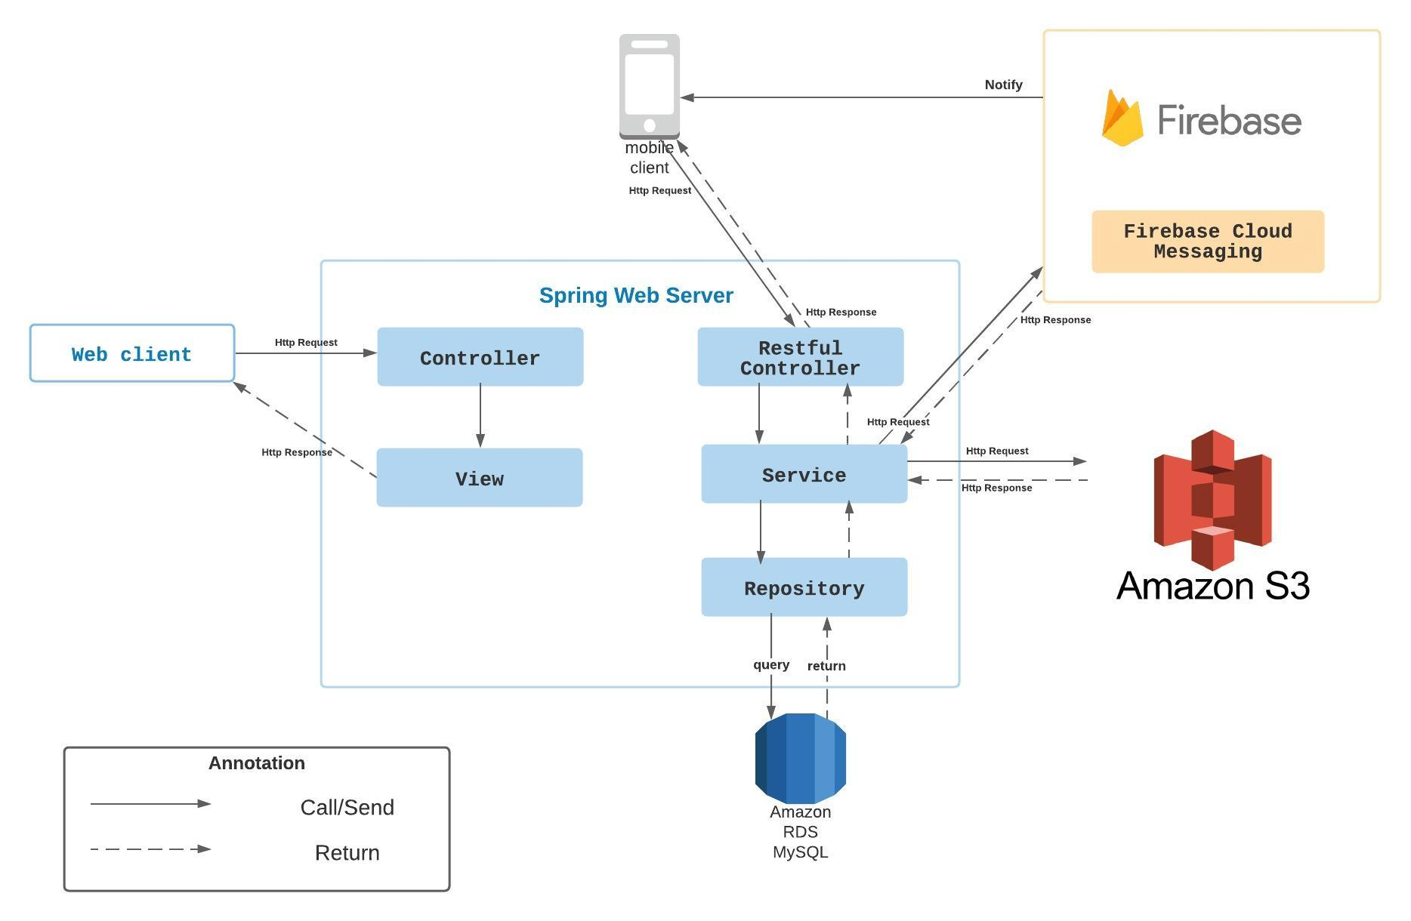

***Figure 1 - System Architecture***

### 2.2 System Architecture

2.2.1 Web server architecture

2.2.2 Mobile app architecture

### 2.3 Package Diagram

*[Provide the package diagram for each sub-system. The content of this section include the overall package diagram(s) and the explanation for each package. Please see the sample and description table format below]*

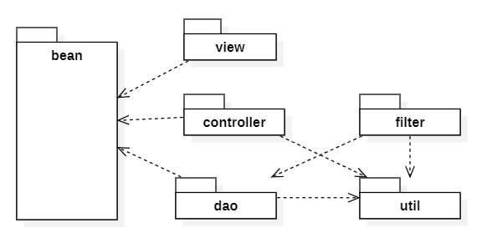

***Code Packages***

|  |  |  |
| --- | --- | --- |
| **No** | **Package** | **Description** |
| 01 | <Package name> | <Description of the package> |
| 02 |  |  |

## 3. System Detailed Design

### 3.1 <Feature Name1>

*[Provide the detailed design for the feature <Feature Name1>. It include Class Diagram, Class Specifications, and Sequence Diagram(s)]*

#### a. Class Diagram

***Figure 2- Class diagram***

#### b. Sequence Diagram(s)

*[Provide the sequence diagram(s) for the feature, see the sample below]*

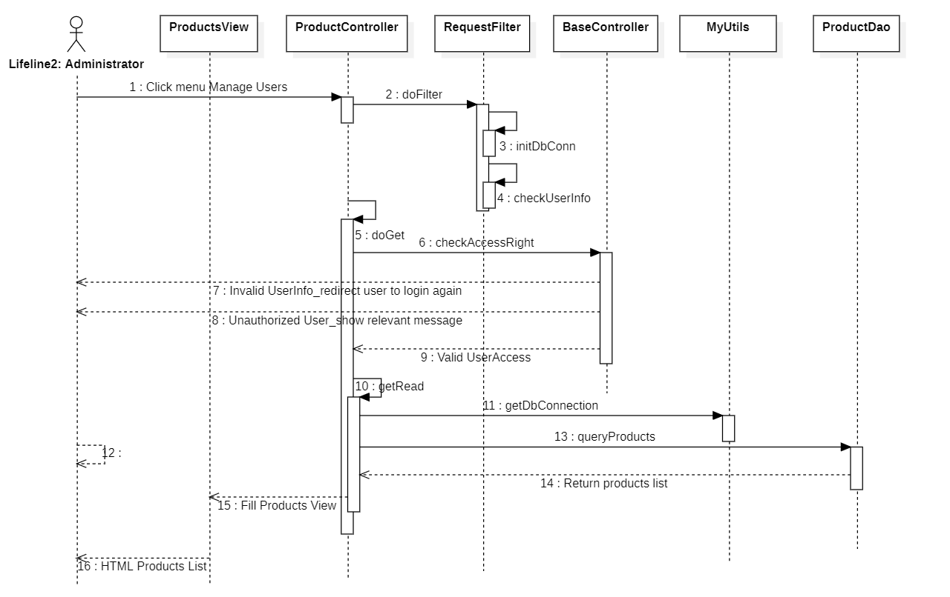

## 4. Class Specifications

### 4.1 XYZ Class

*[Provide the detailed description for the class methods]*

|  |  |  |
| --- | --- | --- |
| **No** | **Method** | **Description** |
| 01 | <method name> | <Description of the method, including the inputs, outputs & internal method processing> |
|  |  |  |

### 4.2 ABC Class

***Class Methods***

*[Provide the detailed description for the class methods]*

|  |  |  |
| --- | --- | --- |
| **No** | **Method** | **Description** |
| 01 | <method name> | <Description of the method, including the inputs, outputs & internal method processing> |
|  |  |  |

### 4.3 …

## 5. Data & Database Design

### 5.1 Database Design

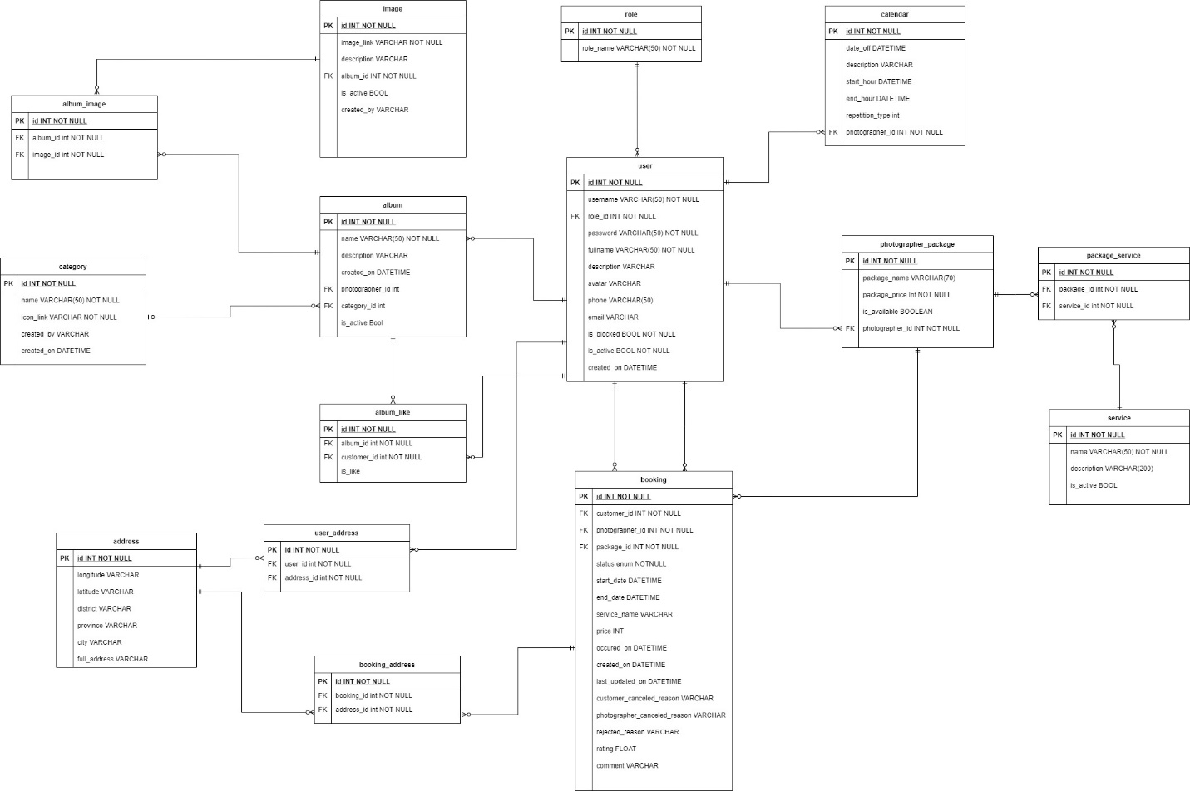

***Figure 3 – Database design***

#### a. User

|  |  |  |  |  |  |  |  |
| --- | --- | --- | --- | --- | --- | --- | --- |
| **#** | **Field name** | **Type** | **Size** | **Unique** | **Not Null** | **PK/FK** | **Notes** |
| 1 |  |  |  |  |  |  |  |
| 2 |  |  |  |  |  |  |  |

#### b. Table name 2…

### 5.2 Data File Design

*[File List, in the table format as below]*

|  |  |  |  |
| --- | --- | --- | --- |
| **#** | **File Name** | **Type** | **Notes** |
| 1 | Class name1 |  |  |
| 2 | Class name2 |  |  |
| 3 | .. |  |  |